Assignment 5 – URL Addresses

- www.yahoo.com – This is the start page I use at home. Yahoo is a very popular search engine, a website used to search and locate things on the internet. 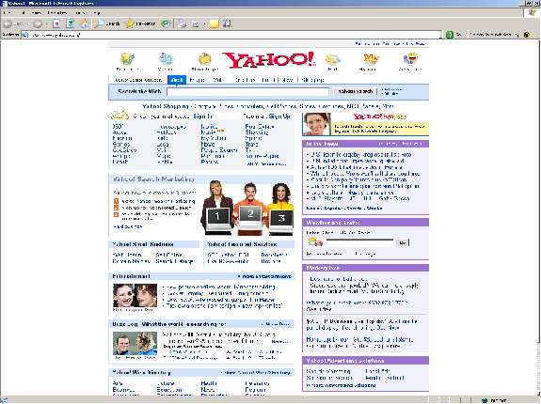
- www.eBay.com – This is the popular auction site I often purchase things from. You can buy anything on eBay, cars, houses, clothes, computers. You can usually get really good deals, too. 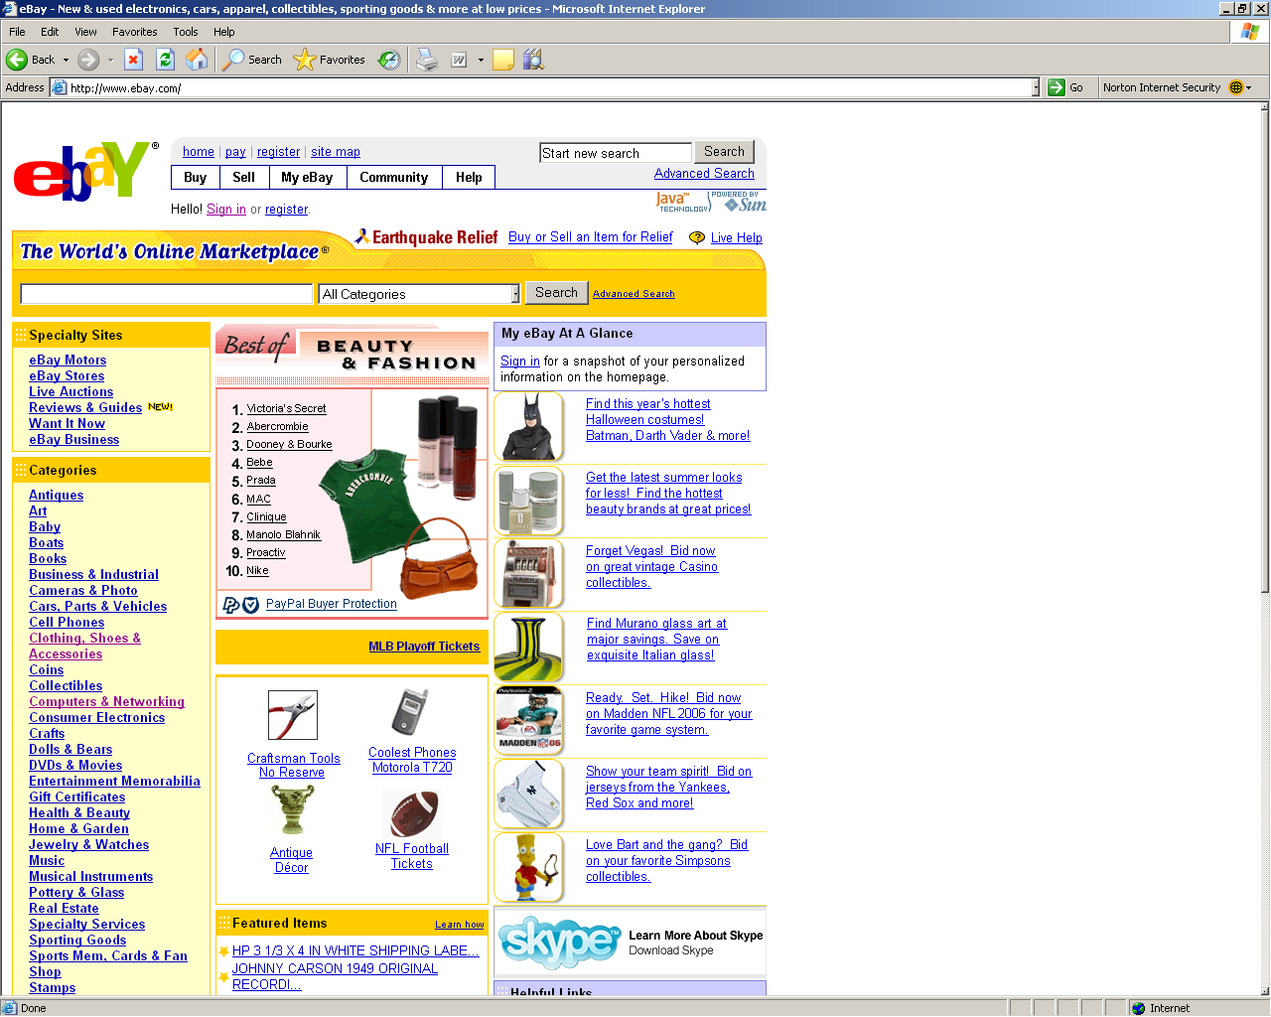
- www.detroitredwings.com – This is the home page for the Detroit Red Wings. I just had to include this now that hockey is back from its layoff due to a lockout. I am a big hockey fan and am very glad to see hockey back. 